A Lifetime of Faith

**Planning Guide & Worksheet**

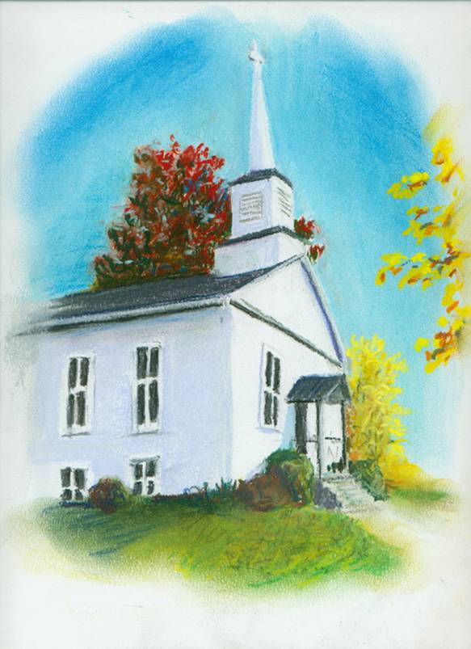

We know that for faith formation to “last a lifetime,” we must coach parents to take a more active role in forming their own children.

**We also know that when parents are coached like this, they love it! They themselves find new faith and a renewed love for the church.**

By evaluating your current programs through the lens of how well you coach parents, you will find that **simple steps and small upgrades** to your current resources will produce fantastic results!

We have designed this **guide** to help you evaluate your current programs and refine them to include ever more coaching for parents.

We recommend that you work with a small group of parish leaders &

review each dimension of your program using the tools presented here.

For each dimension, sketch realistic first steps and create plans and ideas that fit the culture and history of your particular parish.

**The brief plan you create will guide you for the coming years.**

**Table of Contents**

**The plans outlined below are based on coaching parents to take a stronger role in forming their own children, in the context of parish programs. See the book, *Great Expectations*, for more.**

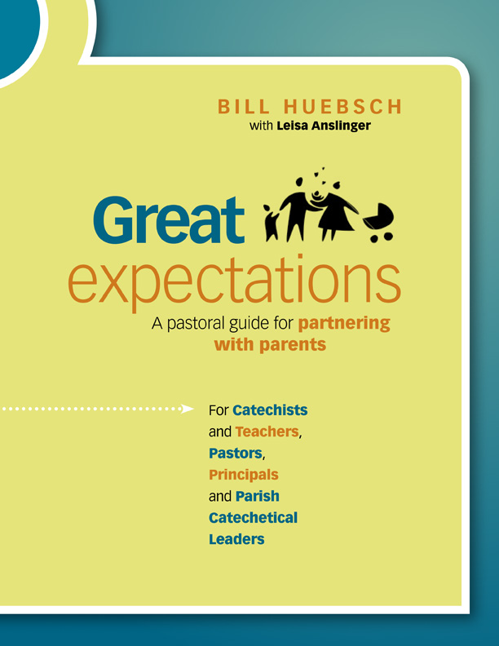

Available at www.PastoralPlanning.com.

**Dimension One:**

Infant Baptism Preparation 3

**Dimension Two:**

After Baptism…Before the first years of school 7

**Dimension Three:**

Preparation for First Confession & First Communion 10

**Dimension Four:**

After Sacrament Preparation:

The Middle Elementary Years 12

**Dimension Five:**

Junior or Senior High

Youth Ministry or Confirmation

& on-going Adult Faith Formation 18

**A Lifetime of Faith**

**Planning Guide and Worksheet**

**Dimension One: Infant Baptism Preparation**

The people responsible for this area of ministry

|  |  |  |
| --- | --- | --- |
| Person working in this ministry | The role which he or she plays | The person who oversees this |
|  |  |  |
|  |  |  |
|  |  |  |
|  |  |  |

If more space is needed, please use the backside of this page.

Describe your current program for this ministry:

What is required of someone who comes to the parish door and asks for baptism for their child? What steps must they take?

**1**

**2**

**3**

**4**

If more space is needed, please use the backside of this page.

Evaluate your current program using this chart. Answer this question: **How do we think young couples or single parents respond to our current program?**

|  |  |
| --- | --- |
| Fill in the appropriate percentages and, talking this over together, complete the bottom portion before going on. | |
| **%** | **Really liked what we offered and wanted more** |
| **%** | **Mainly tolerated what we offered and were happy to see it end** |
| **%** | **Really disliked what we offered and seemed not to find it helpful** |
| What part of your current program seemed to work best? What would you repeat?  If more space is needed, please use the backside of this page. | |

**Coaching Options**

**1. Dual Avenues.**

See pages 25-30 in *Great Expectations.*

Go here on the web site: <http://pastoralplanning.com/Partnership-Parents.html>

**Avenue #1:** Use a baptism prep process which actually coaches parents, rather than merely “teaches” them. Let this be your main criterion when choosing your resource.

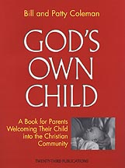

One example of a resource that does this is *God’s Own Child*. It provides coaching for parents who are actively engaged in parish life, or who have a working knowledge and understanding of the Rites and practices of the Church. In the program, moms and dads each consider the core beliefs they hold and are coached to expand that and make it personal in order to pass it on to their child. Single parents are likewise coached to do the same. *God’s Own Child* also addresses the role and needs of non-Catholic parents in raising the child. In sensitive and inclusive language, the non-Catholic is helped to see that he or she shares many of the same beliefs we do, and can pass the values and virtues rooted in them to the child.

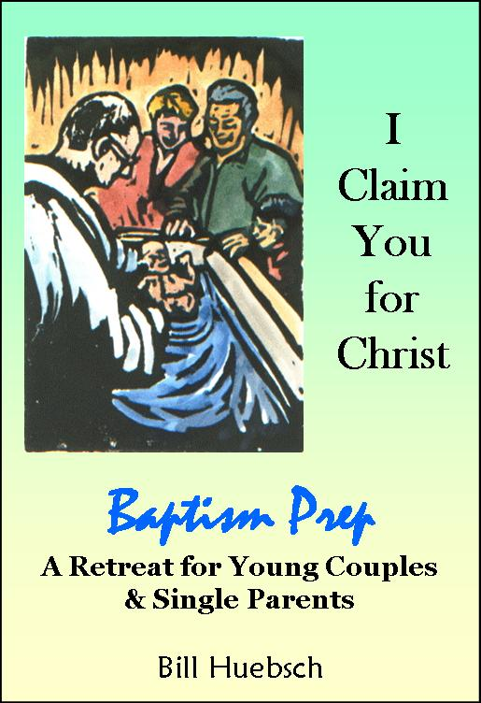

**Avenue #2:** Create dual avenues for preparation. For young parents who are active in parish life, avenue #1 may be enough. But for others, follow avenue #2.

By inviting the young couple or single parent to deepen their own faith and encounter the Living Christ in a retreat-like preparation process, you set the stage for them. You make liturgy more meaningful. And because this retreat includes the Sacrament of Penance within it, you also help them over a common barrier in the way of a more active faith. One such retreat is *I Claim You for Christ*. It is described in detail in *Great Expectations*, pages 29-30. This baptism prep retreat has evangelization as its goal.

**2. On-going coaching for young couples and single parents.**

See pages 25-30 in *Great Expectations.*

Following the use of a good preparation resource and a retreat-like experience such as *I Claim You for Christ*, the **adult parishioners** who volunteer to work as leaders for these experiences may continue to play a role in the life of the young couple or single parent. Why not extend the relationship begun in this process into the following years?

If you intend to do this, laying a plan before the preparation sessions is important. Recruit those adult parishioners who work in baptism prep to take a role in the next phase of coaching -- which occurs *between baptism and the first years of school* for the child.

Before proceeding with this plan, jump ahead one dimension and read the next section of this Guide & Worksheet.

**3. Other options**

As a team, talk through other options resulting from your experience or based on the ones presented here, or a combination of them. What works best in one parish may not work in another as well. Tailoring your approach to your own community is very wise.**Planning**

|  |
| --- |
| What outcome do you want? What do you want parents with baptism-age children to get from their preparation process?  **In the long term:**  **In the short term:**  If you were planning “from scratch” what elements or characteristics of a faith formation process for these parents do you think would be ideal? (See also *Dreams and Visions*, pages 145-146).  **A. Leading to deeper communion with Christ?**  **B. Leading to a greater understanding and practice of the Catholic faith?** |
| **Resources & First Steps.**  A. What first steps will you take with this group, or how will you enhance what you offer now?  B. What faith formation resources will you use to take those first steps?  C. What will this cost? Where will it come from in the budget? Who will do it? |

**A Lifetime of Faith**

**Planning Guide and Worksheet**

**Dimension Two:**

**After Baptism…Before the first years of school**

The people responsible for this area of ministry, in any:

|  |  |  |
| --- | --- | --- |
| Person working in this ministry | The role which he or she plays | The person who oversees this |
|  |  |  |
|  |  |  |
|  |  |  |
|  |  |  |

If more space is needed, please use the backside of this page.

Describe your current program for this ministry

**Coaching Options**

We suggest you name a staff person or volunteer to serve as **“The Pastoral Coach”** in this area of parish life. This person would follow some or all of these options:

See page 30 in *Great Expectations* **Go here on the web site:**

<http://pastoralplanning.com/Partnership-Parents.html>

**1. For couples or single parents who are already active in parish life.**

* The pastoral coach would be their “cheerleader,” making sure young couples and single parents are included in the language and activities of the wider parish.
  + Young couples and single parents often become invisible, mainly because they are busy with their daily lives and unable to donate a lot of time and money to parish life.
* This person would maintain THE LIST of such households in the parish, and pay attention to their unique needs.
  + Are there special-needs children?
  + Is this a single parent who needs more support?
  + Is this a family living far from its extended tribe?
  + Is this a household living with illness?
  + Do these households have everything they need to create a truly “Catholic home?”
  + Is there a need for more formal contact, such as that provided through *Entrusted to Your Care*?

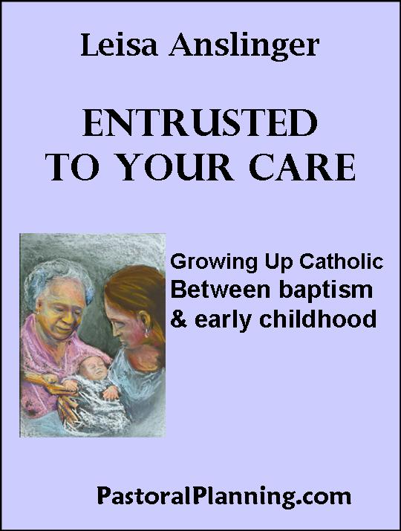

* + And so forth
* The pastoral coach would also keep an eye on the needs of such households at Sunday liturgies and parish activities:
  + Do they need childcare?
  + Would some level of pre-school program be needed?

**2. For young couples or single parents who are not active in parish life.**

* The pastoral coach would make use of a program to keep in touch with them, such as *Entrusted to Your Care*
* This resource includes annual and seasonal letters and invitations, prayer resources for the household, and other tools to help the pastoral coach keep a strong **relationship** active between the parish and these households.

**Planning**

|  |
| --- |
| What outcome do you want? How do you want parents with children to be connected to the parish?  **In the long term:**  **In the short term:**  If you were planning “from scratch” what elements or characteristics of a faith formation process for these parents do you think would be ideal?  **A. Leading to deeper communion with Christ?**  **B. Leading to a greater understanding and practice of the Catholic faith?** |
| **Resources & First Steps.**  A. What first steps will you take with this group, or how will you enhance what you offer now?  B. What faith formation resources will you use to take those first steps?  C. What will this cost? Where will it come from in the budget? Who will do it? |

**A Lifetime of Faith**

**Planning Guide and Worksheet**

**Dimension Three:**

**Preparation for First Confession & First Communion**

The people responsible for this area of ministry

|  |  |  |
| --- | --- | --- |
| Person working in this ministry | The role which he or she plays | The person who oversees this |
|  |  |  |
|  |  |  |
|  |  |  |
|  |  |  |

If more space is needed, please use the backside of this page.

Describe your current program for this ministry

In your current program, **how well do you actually coach parents to form their own children? Rate your parish:**

1 2 3 4 5 6 7 8 9 10

poorly a little somewhat quite a bit a lot they do it all

Comments:

Evaluate your current sacrament prep program using this chart. Answer this question: **How do we think young couples or single parents AND THEIR CHILDREN respond to our current program?**

|  |  |
| --- | --- |
| Fill in the appropriate percentages and, talking this over together, complete the bottom portion before going on. | |
| **%** | **Really liked what we offered and wanted more** |
| **%** | **Mainly tolerated what we offered and were happy to see it end** |
| **%** | **Really disliked what we offered and seemed not to find it helpful** |
| What part of your current program seemed to work best? What would you repeat?  If more space is needed, please use the backside of this page. | |

**Coaching Options**

See *Great Expectations*, pages 30-31 and the Appendix beginning on page 50.

On the web site, go here: [www.GrowingUpCatholic.com](http://www.GrowingUpCatholic.com).

1. Use your existing textbook series or companion books for Sacrament Prep.

* But build in a component to coach parents, based on the models you have seen in *Great Expectations.*
* Gather parents-with-their-children for learning sessions
  + Don’t merely send home the book and hope they can find their way through it by the time the first sacraments are being offered. Most parents cannot do this, even many who are actively engaged.
* Provide catechist-coaches to guide the parents in the learning session, using the materials you prepare for them.

2. Create or buy a resource designed to coach parents.

(See Chapter Five, starting on page 45 of *Great Expectations.*)

* As above, hold learning sessions in which the parents are seated with their children for Sacrament Prep.

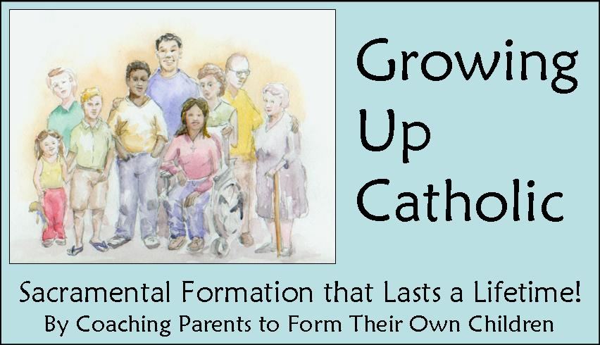

* The catechist-coach guides both parents and children through the resource, parents serving as the primary teachers.
* One such resource, or one that you could use as a model, is *Growing Up Catholic*. Es disponible en español, también. A sample of this is provided at the end of this Planning Guide.
* The room you use might look like this:



**Note:** In your planning on the following pages, bear in mind that coaching parents is unlike classroom teaching. When you coach, you need a resource which is more of a handout than a book (although some books are designed with parents in mind and work very well).

**Planning**

|  |
| --- |
| What changes are possible for you to make in your Sacrament Prep process for this coming year? What do you want parents and children at this age to get from their preparation process?  **What do you want them to take home with them?**  **What role do you want parents to play?**  ----------------------------------------------------------------------------------------------------------------------------  **Getting Organized**  **What steps are needed to get started in this new direction?**  **Who will take those steps?** |
| **Resources & First Steps.**  A. What faith formation resources will you use to take those first steps?  C. What will this cost? Where will it come from in the budget?  D. What room or spaces can you use? |

**A Lifetime of Faith**

**Planning Guide and Worksheet**

**Dimension Four:**

**After Sacrament Preparation**: grades 3, 4, 5, and 6 or higher

In most parishes, these are simply known as the middle elementary years during which the youngsters are taught by a catechist in a religious ed or school setting, mainly with their parents absent. Most parishes and schools use a standard children’s religion textbook during this period.

The people responsible for this area of ministry

|  |  |  |
| --- | --- | --- |
| Person working in this ministry | The role which he or she plays | The person who oversees this |
|  |  |  |
|  |  |  |
|  |  |  |

If more space is needed, please use the backside of this page.

Describe your current program for this ministry

In your current program, **how well do you actually coach parents to form their own children? Rate your parish:**

1 2 3 4 5 6 7 8 9 10

poorly a little somewhat quite a bit a lot they do it all

Comments

**Coaching Options**

***Partnering with Parents in the middle elementary years***

See pages 31-34 in *Great Expectations*.

Many parishes experience a significant drop-off in the number of parents who enroll their children in religious education programs after Grade 2 and the first sacraments.

* Do parents believe that they have “done their duty” by completing the first sacraments and now feel they can take a break until their child is old enough to prepare for Confirmation?
* Do parents feel unwelcome or uninvited into this part of their children’s religious education? Are they possibly, in fact, *not welcome*?
* How do you extend a real, warm invitation to parents to become part of this process on a regular enough basis that they
  + are being formed themselves by it?
  + know what their children are learning and take part in it?

**1.** Read the material in Great Expectations on pages 13-34 about the using “**Learning Centers for Parents**.”

* Such learning centers occur while the children are in their regular parish religious ed class
* Or for parents with children in the school, on an evening or Saturday morning.

**2.** Also become familiar with the material describing

“**Whole Family Catechesis**” in the same section of *Great Expectations.*

* If you are familiar with inter- or multi-generational learning, such as that offered through *Generations of Faith*, you will recognize much in this that is the same.

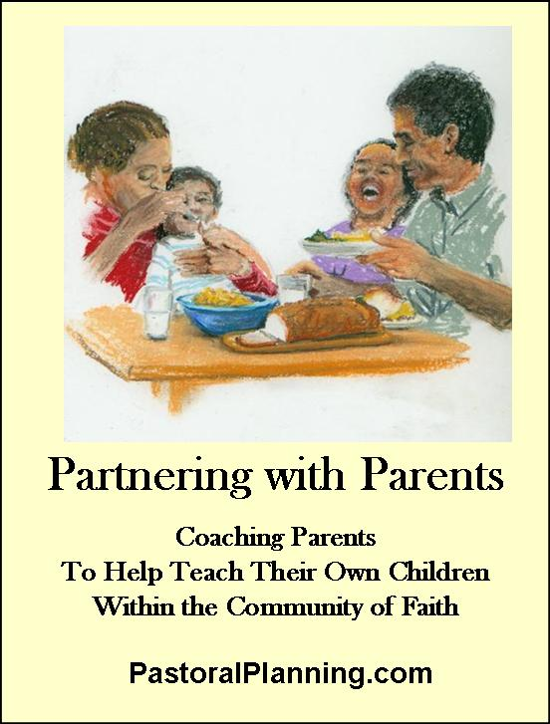

* + The key difference is that in this setting, parents sit with their children and are coached to form them.

**The themes** for either **Learning Centers** or **Whole Family Catechesis** flow directly from the children’s textbooks. For example, while the children are in Unit #1 on God and Creation or Revelation, parent sessions are on the same theme. **You can create these programs yourself.**

OR: Everything needed to host such parent sessions, all in outline form and including prayer, handouts, check-lists, and talking points, *is available on the web site here:* <http://pastoralplanning.com/Partnership-Parents.html>

**The Themes**

***for Partnering with Parents in the middle elementary years***

|  |
| --- |
| Our Inborn Hunger for God  Often a key theme on which to begin. This is where the *Catechism* itself starts – the recognition that we all hunger for unity with each other and with God. |
| How God Reveals Himself  In many textbooks, this is the first unit. It deals with the nature of God and how God reveals himself to us humans. For parents, it is important to speak to their children about God as he is revealed in nature, a loving home, acts of kindness, or even in times of trouble. |
| The Blessed Trinity  The heart and soul of our faith is our belief in the Blessed Trinity, a community of divine love, expressing itself to us, inspiring and guiding us, and creating us. This is one area where parents often feel least equipped to talk with their children. |
| The Person of Jesus Christ  What could be more important for parents than to be able to speak with their children about the life and person of Jesus Christ. To know the stories and, more importantly, to know Christ as a shared friend and teacher. |
| The Nature of the Church  This is a key unit in the children’s textbooks because for many children attendance at Mass and other parish functions is rare. coaching parents here leads them to fuller participation, to modeling this for their children, and to re-joining the community. |
| Catholic Morality  In today’s world and culture, having parents who are fully knowledgeable about Catholic moral teachings is more vital than ever before. |
| The Liturgy and the Sacraments  As Catholics, we are a sacramental people. Knowing and understanding our liturgical life will help parents speak clearly about it to their children. |
| The Reign of God  Our mission is to help build the Reign of God on earth. It’s very important to coach parents on what this means and how each household is a reflection of this Reign. |
| The Mass – Intro Rites, Lit of Word & Eucharist  Of all the liturgical celebrations in the Church, none is more important for parents to know well than this. Each part of the Mass is examined and explained fully. |
| Sacred Scripture  Once parents are coached to make the Bible a more central part of household life, it will pass on to their children. They will come away with confidence about the Bible. |
| Christian Prayer  Daily prayer is a hallmark of being a follower of Jesus. We Catholics bring centuries of tradition and a strong connection to God through prayer. |
| Catholic Social Teachings  When parents are prepared to speak to their children about the events of business, politics and social life through the lens of our social teachings, their children learn from them. |

**Planning**

|  |
| --- |
| How can your parish organize in either or both of these options?  **Learning Centers for Parents?**  **Whole Family Catechesis?**  ----------------------------------------------------------------------------------------------------------------------------  **Getting Organized**  **What steps are needed to get started in this new direction?**  **What will the calendar look like for next year?**  **Who will take those steps?** |
| **Resources & First Steps.**  A. What faith formation resources will you use to take those first steps?  C. What will this cost? Where will it come from in the budget? What space do you need? |

**A Lifetime of Faith**

**Planning Guide and Worksheet**

**Dimension Five:**

**Junior or Senior High:** Youth Ministry or Confirmation

**On-going Adult Faith Formation**

It is commonly believed that either (1) young adults don’t want their parents present for faith formation during these years, or (2) parents themselves don’t want to be present during formation sessions. In fact, when you bring parents into the mix, using a process which is friendly to all, both parents and young adults have a much better chance of growing in their faith now and for the rest of their lives.

The people responsible for this area of ministry

|  |  |  |
| --- | --- | --- |
| Person working in this ministry | The role which he or she plays | The person who oversees this |
|  |  |  |
|  |  |  |
|  |  |  |

If more space is needed, please use the backside of this page.

Describe your current plan for Confirmation or Youth Ministry Formation:

The persons are named above. But what texts or resources do you use? What two major outcomes do you plan for?

**1**

**2**

In your current program, **how well do you actually coach parents to form their own children? Rate your parish:**

1 2 3 4 5 6 7 8 9 10

poorly a little somewhat quite a bit a lot they do it all

Comments

In your current program, **how well do you actually coach sponsors to take a planned, active role in Confirmation preparation? Rate your parish:**

1 2 3 4 5 6 7 8 9 10

poorly a little somewhat quite a bit a lot they do it all

Comments

**This is a key period of a young person’s life,** one in which his or her faith is growing and maturing. Even if parents have been absent up to this point in the young person’s faith formation, there is still time to invite them in and provide a forum in which Catholic faith, life and culture can be explored, and the Creed we all share can be integrated into the beliefs of both parent and young adult.

This is the moment when both parent and young adult take steps down a lifelong journey of faith. **Coaching Options**

See *Great Expectations*, pages 34-35.

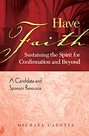

**1.** **For Sponsors.** We cannot find another resource better than *Have Faith* from Mike Carotta. In this lovely, inexpensive book, both young adults and sponsors are coached to be in touch with each other on vital matters of faith – whether that’s by E-mail, Twitter, Facebook, in Person, or by Phone. This is simply the best.

There is a *Have Faith* leader’s guide available as well, written by the same author and very user-friendly. We recommend it.

**2.** **For Young Adults and Adults: Mini-Courses**

In these sessions, adults or young adults (junior or senior high) and their parents, sponsors, or other adults gather together in the same room. They are seated as small groups, two or three household groups forming each **Discussion Group.**

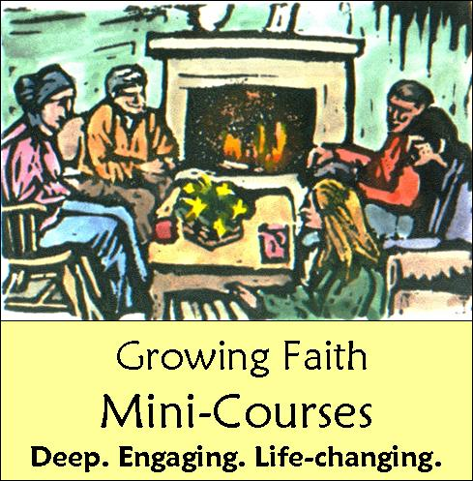

The **Discussion Groups** employ a teaching method created for the purpose of coaching parents or other adults and youth together. It is called **Learn & Teach.** In this method, each **Discussion Group** learns a segment of the session material well enough to turn around and teach it to their peers in the whole group. Both youth and adults work together, both learning and both teaching.

The resource used for the **Learn & Teach Method** is the key. The resource works best if it is in pamphlet or booklet format. These can easily be sent home with the household group. In this method, the resource is studied and dissected before being outlined in order to teach it to others. Having a resource in plain English (or whatever language you need) is a very strong idea. Several good booklet-style resources are available, and it is probably best not to try to create this from scratch in your own parish. Here is a partial list of possible resources:

* Catholic Update, from St Anthony Messenger Press
* Scripture from Scratch, from Liguori
* *Growing Faith,* from Twenty-Third Publications & OSV Curriculum.

**Planning**

|  |
| --- |
| How can your parish organize to include parents, sponsors or other adults more fully in the Confirmation preparation or Youth Ministry Formation process?  **For Sponsors?**  **For Parents, Guardians or other adults?**  ----------------------------------------------------------------------------------------------------------------------------  **Getting Organized**  **What steps are needed to get started in this new direction?**  **What will the calendar look like for next year?**  **Who will take those steps?** |
| **Resources & First Steps.**  A. What faith formation resources will you use to take those first steps?  C. What will this cost? Where will it come from in the budget? What space do you need? |